Cover Page
Mosaic of North Central Wisconsin
April 2023
What is Diversity, Equity and Inclusion (DE&I)?

Diversity
The similarities & differences among individuals accounting for all aspects of their personality and individual identity, including such dimensions as age, race, ethnicity, religion, gender, sexual orientation, physical abilities, knowledge base, reasoning skills, problem-solving style, life experience and many others.
Equity
Policies and practices that allow fair treatment in access, opportunity and advancement for all individuals while striving to identify and eliminate barriers that have prevented the full participation of some groups.
Inclusion
A culture that allows each person in an organization to feel welcomed, respected, supported and valued as a team member so individuals can contribute and thrive to their fullest potential.

Not all similarities and differences among team members are visible:
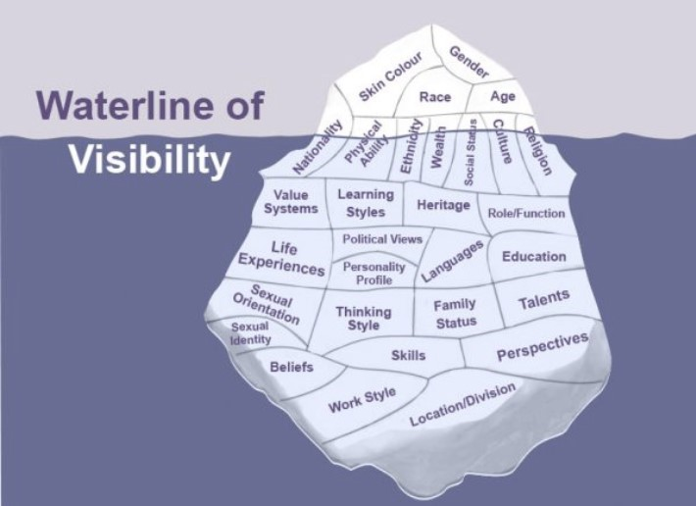

The Business Case for DEI
Include introduction of how the company has approached DE&I/ corporate culture in the past…
The evolving business climate and demographic shifts in the workforce demand a need for change. And it isn’t enough to have diversity among our team members; each employee must feel comfortable enough to share his or her ideas.
Research strongly suggests when companies implement a systematic, business-led approach to DE&I, they are better able to attract top talent, improve employee engagement and decision-making, innovate faster and be more customer-oriented.

“The business case for inclusion and diversity is stronger than ever. For diverse companies, the likelihood of outperforming industry peers on profitability has increased over time, while the penalties are getting steeper for those lacking diversity.”

McKinsey & Company
May 2020

Attract and Engage Talent
“35% of an employee’s emotional investment in their work and 20% of their desire to stay at their organization is linked to feelings of inclusion.” (Catalyst June 2020)
“Recent demographic trends create a business case for diversity and inclusion that relies on market logic of supply and demand.” (The Diversity Bonus 2017)
Innovation and Group Performance
“Diverse teams are critical for innovation earning 38% more of their revenues, on average, from innovative products and services.” (The Boston Consulting Group 2017)
Customer Understanding
“The business case for diversity and inclusion theorizes that in a global marketplace, an organization that employs a diverse workforce is better able to understand the demographics of the marketplace it serves and is thus better equipped to thrive in that marketplace.“ (MRA 2017)
Reputation and Responsibility
“Employees who view their workplace as inclusive are also likely to consider their organizations to have ethical value.” (Harvard Business Review 2019)
Financial Performance
“Many studies link diversity to indicators of profitability and financial health.” (Catalyst 2020)
“Companies that value diversity see a 35% greater chance of higher financial returns than their national industry median.” (McKinsey & Company 2015)

How does DE&I align with our business objectives?
To remain relevant in today’s global business world and as we look to expand our company and our talented workforce, we must be intentional about our DE&I efforts.
Make your case on this page – How do your objectives tie to the categories on the previous page?

(new page)
How are we doing now?
Include relevant data points – both successes and challenges; can pull information from employee engagement surveys, EEOC demographics,

Example:
7 of 7 | 64% | 13% | 5 of 7 | 1 of 7
locations  have a gap in ethnic  minority representation | team members  are ethnic minorities, the highest % location  in the company | supervisors  across the company are ethnically diverse | locations  minorities are  underrepresented at  manager level+ | executive team members  are female

Where do you find DE&I best practices?
A recent MRA survey of member companies showed that only 16% of have a formal DEI initiative or plan with goals and metrics. Out of those who do not, the majority indicated they are making efforts of limited scope or are at the beginning stages of their initiative. Recent world events will certainly increase the number of companies like ours that are entering their DE&I journeys – not just because “it’s the right thing to do,” but because it makes good business sense.

Our DE&I Core Team is engaging is extensive research, including subject leaders like Catalyst and Diversity Inc., through interviews with companies practicing intentional DE&I efforts, attending learning events and reading books about DE&I. Our Core Team is committed to learning, researching and serving as our company’s DE&I subject-matter experts. The information in this business case is a result of our Core Team’s research and information-gathering.

What companies are we researching? (Choose some from your industry)
Our Core Team is researching DE&I best-practice companies from the following pools: DiversityInc. top-rated employers, Forbes list top employers, HVAC companies, and professional partners. Research is conducted through direct interviews with company representatives and/or online company dashboards/reports. This research began in July 2020 and is ongoing.

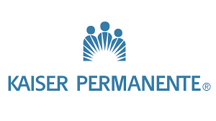

What are DE&I best practices?
Companies of all sizes representing all industries have started the diversity, equity and inclusion journey. Some are decades into their work, while many others are just beginning. Their hard work and willingness to share results, challenges and wins helps create a foundation of best practices from which companies like ours can draw.
In our research, the best practices found for developing a diverse and inclusive workplace include:

Additional Key DE&I Best-Practice Findings
- It is critical to have diversity at top leadership roles to reflect the organization’s commitment to diversity.
“We’re focused on creating a more inclusive culture that values all dimensions of diversity, because we know a more diverse culture fosters a more innovative culture, and innovation fuels our growth.”

Medtronic CEO

- You have to link DE&I to the organization’s mission, business strategy and performance goals.
- View DE&I as central to the company culture / core values and a significant driver of financial value.
- All employees must understand the business case for DE&I and embrace inclusion in everything they do.
- You must have dedicated DE&I resource/s with a council of team members.
- Must focus on all three: diversity, equity and inclusion.
- Evaluate and monitor compensation program to ensure pay equity.
- Evaluate benefit programs to be flexible & inclusive.
- Metrics are established to measure progress, and employees
are recognized for DE&I achievements, e.g. BU/leadership/
individual/team performance goals.
- DE&I is fully integrated with the talent-management strategy, including recruitment, employee development and promotions.
Church Mutual CEO

- Build relationships with diverse professional groups, community organizations, and colleges/universities to identify and recruit talented individuals.
“Church Mutual is an open tent that welcomes all faiths, all backgrounds, all cultures and every individual. Diversity is absolutely critical to the success of this organization. It is a personal priority for me and strongly supported by our leadership team and board of directors.”

- Start with listening and education with all team members.
- Implement mentorship program (reverse mentoring as well).
- Don’t move too fast. This journey takes time.
- Support flexibility in the workplace.
- DE&I is as a key leadership competency.
- Establish a diversity-sensitive process for resolving conflicts that emerge around race, ethnicity, gender or other diversity related issues, e.g. an ethics hotline.
- Host listening sessions/forums to foster a culture of open communication/transparency for discussions around DE&I.
- Support Employee Resource Groups & Employee Networks (veterans, women, LGBTQ+, Black, Hispanic, physical disability, young professionals).
- It is essential to have a Supplier Diversity Program.
- Promote/communicate DE&I actions and progress (dashboard) within the organization (internally & externally).
Our Core Team Mission
Insert your group’s mission

Priority Action Items – Year 1

Additional pages can include: Example strategy (recruitment, for example) and an addendum with more data

